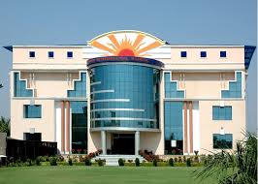

**SUN INTERNATIONAL SCHOOL**

**COMPUTER PROJECT**

Topic –Music Library

Submitted to- Submitted by-

Mrs. Nishtha Chaubey Vyas Pragati Gupta

**10th-B**

**PREFACE**

With the advancement of technology ,rapid globalization ,diversified and multifaceted stimulants ,children and young people are commonly intelligent and quick minded.

As a part of the course curriculum and to deepen and widen the practical knowledge in the concept of HTML , I have made a project on the same.

Working on this project , I came to know and understand the various aspects of the topic “MUSIC LIBRARY” , at the same time the very importance of creativity and knowledge I student’s life.

I have expressed my experiences in my own simple way .I hope who goes through it will find it interesting and worth reading. All constructive criticism and feedback is cordially invited.

**Pragati Gupta**

**10th –B**

**Acknowledgement**

I am very thankful to everyone who all supported me, for I have completed my project effectively and moreover on time. I am overwhelmed in all humbleness and gratefulness to acknowledge my depth to all those who helped me to put these ideas well. I am equally grateful to my computer teacher - Mrs. Nishtha Chuabey Vyas. They gave me moral support and guided me in different matters regarding the topic - “Music Library”.

With the help of their valuable suggestions, guidance and encouragement, I was able to perform this project work. Last but not the least, I would like to thank my parents who helped me a lot in gathering different information, collecting data and guiding me from time to time. Despite of their busy schedules, they game me their precious time in making this project unique.

**Pragati Gupta**

**10th-B**

**INDEX**

|  |  |  |
| --- | --- | --- |
| 1. | PREFACE | 2 |
| 2. | ACKNOWLEDGEMENT | 3 |
| 3. | INDEX | 4 |
| 4. | INTRODUCTION | 5 |
| 5. | HTML BASICS | 6 |
| 6. | CODING | 9 |
| 7. | WEB PAGES | 36 |
| 8. | FUTURE SCOPE | 45 |
| 9. | REFERENCES | 46 |

**introduction**

A music library contains music-related materials for patron use. Collections may also include non-print materials, such as digitized music scores or audio recordings. My project consist of two types of music library : Instrumental music library and Vocal music library.

An instrumental music is a recording without any vocals, although it might include some inarticulate vocals, such as shouted backup vocals in a Big Band setting.

Vocal music is a type of singing performed by one or more singers, either with instrumental accompaniment, or without instrumental accompaniment (a cappella), in which singing provides the main focus of the piece.

Through my project ,you will able to know the top 3 vocal and instrumental music artists of our country, INDIA and their best covers. This library will provide you the audios and videos of their top covers.

The intention of this music library is to let us understand and feel music and appreciate the artists for bringing such amazing songs , covers and mashups. Through the covers that I have put ,you will meet each emotion of life i.e., happiness , joy ,sadness , patriotism , love , hatred , mischief , anger and friendship.

I sincerely hope that you will find the music library useful as it will also help you to know the biography, journey and awards of the artists.

**HTML BASICS**

**What is HTML ?**

It stands for Hyper Text Markup Language . HTML is a complete code package that allows a user to create web pages .It includes test and graphics. Using HTML, we can add links to web pages.

Hyperlinks are the highlighted text segments or images that connect to other pages on the web. Let us analyze the word HTML.

HYPER TEXT : Hyper Text is the text used to link various web pages. It is the text on the web page, which on clicking opens a new web page.

MARK-UP : It means highlighting the text either by underlining or displaying it in different color, or both.

LANGUAGE : It refers to the way of communication between web pages, which has its own syntax and rules.

**What is a Tag ?**

HTML is a **Tag** based language. Tag is an element, which instructs the web browser, what to show and how to show. It shows the structure and appearance of a document or a web page that is created. The HTML tags or commands are inserted before and after the text written by user to indicate its format and location on the page. We can use various attributes in the tags that contain additional information like formatting effects, alignments, colors, etc. Each tag giving a specific instruction is enclosed in angle brackets <>.

**HTML document structure**

The general structure of an HTML document has two sections : **Head** and **Body**.

**HEAD SECTION** : The Head section contains the Title that identifies the first part of an HTML coded document.

**BODY SECTION** : The body section is where we do most of the work. It includes text, graphics, and other HTML elements that provide control and formatting of a page like : fonts, paragraph, list and other elements. The general format of an HTML document is :

<HTML>

<HEAD>

<TITLE>

Title of the Web page

</TITLE>

</HEAD>

<BODY>

Text, which you want to show on your web page will

Be given here.

</BODY>

</HTML>

**Some Important Tags**

1. HEADING - <H1></H1> to <H6></H6>
2. PARAGRAPH - <P></P>
3. CENTER - <CENYTER></CENTER>
4. FONT - <FONT FACE = “” SIZE = “” COLOR = “”></FONT>
5. BODY - <BODY BGCOLOR = “” ></BODY>
6. BREAK A LINE - <BR></BR>
7. HR - <HR SIZE = “” COLOR = “” WIDTH = “”>
8. UNORDERED LIST - <UL> <LI> </UL>
9. ORDERED LIST - <OL> <LI> </OL>
10. INSERTING A IMAGE - <IMG SRC=”” ALIGN = “”>
11. INTERNAL LINKING - <A HREF=”#LINKNAME”>LINK TO ANOTHER SECTION OF THE SAME DOCUMENT </A>

<A NAME = “LINKNAME”>

1. EXTERNAL LINKING - <A HREF = “LINKNAME”>NAME TO THE LINK </A>
2. ADDING A TABLE - <TABLE> <TR> <TD> </TD> </TR> </TABLE>

14.FOR FLOATING TEXT -<MARQUEE>

**CODING**

**1.Music Library(Home Page)**

<!DOCTYPE HTML>

<HEAD>

<STYLE>

HR{WIDTH:70% ; COLOR:NAVY;}

</STYLE>

<TITLE>

MUSIC LIBRARY

</TITLE>

</HEAD>

<BODY>

<BODY BGCOLOR = "RAINBOW">

<IMG SRC = "ab.png" ALIGN = "RIGHT" HEIGHT = 180 WIDTH = 210>

<CENTER>

<FONT FACE ="ALGERIAN" SIZE = "16" COLOR = "BLUE">

MUSIC LIBRARY

</FONT>

</CENTER>

<MARQUEE>

<FONT FACE="TIMES NEW ROMAN" SIZE="4" COLOR="BLACK">

BY:-PRAGATI GUPTA <PRE>10th B</PRE>

</FONT>

</MARQUEE>

<HR>

<BR>

<BR>

<P ALIGN = "LEFT">

<FONT FACE = "CALBIRI" SIZE = "5" COLOR = "BLACK">

<B>

<I>

A music library contains music-related materials for patron use. Collections may also include non-print materials, such as digitized music scores or audio recordings. Use of such materials may be limited to specific patron groups, especially in private academic institutions. Music library print collections include dictionaries and encyclopedias, indexes and directories, printed music, music serials, bibliographies, and other music literature.

</I>

</B>

</FONT>

</P>

<HR>

<BR>

<FONT FACE = "CHILLER" SIZE = "6">

Contents

</FONT>

<BR>

<OL TYPE = 1>

<FONT SIZE = "5">

<LI><A HREF = "#Types of Music Library">Types of Music Library</A>

<LI><A HREF = "#Uses of Music Library">Uses of Music Library</A>

<LI><A HREF = "#Have a Look here also">Have a Look here also</A>

</FONT>

</OL>

<BR>

<BR>

<HR>

<IMG SRC = "ABC.JPG" ALIGN = "RIGHT" HEIGHT = 300 WIDTH = 300>

<A NAME="Types of Music Library">

<FONT FACE ="CALBIRI" SIZE="6">

<B>

<I>

<U>

TYPES OF MUSIC LIBRARY

</B>

</I>

</U>

</FONT>

<BR><BR>

<FONT SIZE ="4">

Traditionally, there are four types of music libraries:

<BR><BR>

<UL TYPE=DISC>

<LI>Those developed to support departments of music in university or college settings.

<LI>Those developed to support conservatories and schools of music.

<LI>Those housed within public libraries.

<LI>Those developed as independent libraries or archives supporting music organizations.

</FONT>

</UL>

<BR><BR><BR>

<HR>

<IMG SRC = "PRA.JPG" ALIGN = "RIGHT"HEIGHT = 180 WIDTH = 210>

<BR><BR>

<IMG SRC = "LIBR.JPG" ALIGN = "RIGHT"HEIGHT = 180 WIDTH = 210>

<A NAME="Uses of Music Library">

<FONT FACE ="CALBIRI" SIZE="6">

<B>

<I>

<U>

USES OF MUSIC LIBRARY

</B>

</I>

</U>

</FONT>

<BR><BR>

<FONT SIZE="4">

<UL TYPE=SQUARE>

<LI>Production music libraries license their copyrighted music for use in film, television, and radio productions.

<LI>Performance libraries serve performing music groups, particularly large orchestras, by acquiring, preparing, and maintaining music for performance.

<LI>Digital music libraries and archives preserve recordings and digitized scores or literature in a variety of electronic formats. Many music libraries dedicate part of their duties to digitizing parts of their collection and maintaining digital files. Digital preservation requires specific procedures to avoid decay, obsolescence, and loss. Digital materials may be part of a larger, physical collection, or may compose an entirely electronic collection not physically accessible (usually housed on a network or on the Internet). Access may be limited as a fee-based service, a private service to specific user groups (such as students at a conservatory), or freely accessible to the public.

</FONT>

</UL>

<BR><BR><BR>

<HR>

<IMG SRC = "PQR.JPG" ALIGN = "RIGHT" HEIGHT = 300 WIDTH = 300>

<A NAME="Have a Look here also">

<FONT FACE ="CALBIRI" SIZE="6">

<B>

<I>

<U>

HAVE A LOOK HERE ALSO

</B>

</I>

</U>

</FONT>

<BR><BR>

<FONT SIZE="4" face="freestyle script">

<UL TYPE="CIRCLE">

<LI><A HREF= INSTRUMENTALMUSICLIBRARY.HTML> Instrumental Music Libray</A>

<LI><A HREF =VOCALMUSICLIBRARY.HTML>Vocal MusicLibrary</a>

</UL>

</FONT>

<HR>

<FONT FACE = "CHILLER" size = "7" >

Just click on the above links to know more. !!!!

</FONT>

</BODY></HTML>

**2.Instrumental Music Library (Page-2)**

<!DOCTYPE HTML>

<HEAD>

<STYLE>

HR{WIDTH:70% ;HEIGT:20%; COLOR:MAROON;}

P{FONT-FAMILY:CALBIRI;FONT-SIZE:X-LARGE;FONT-STYLE:ITALIC;FONT-WEIGHT:BOLD;}

</STYLE>

<TITLE>

INSTRUMENTAL MUSIC LIBRARY

</TITLE>

</HEAD>

<BODY>

<BODY BGCOLOR = "AQUA">

<CENTER>

<FONT FACE ="ALGERIAN" SIZE = "16" COLOR = "MAGENTA">

INSTRUMENTAL MUSIC LIBRARY

</FONT>

</CENTER>

<BR><BR>

<MARQUEE>

<FONT FACE="COMIC SANS MS" SIZE="5" COLOR="BLACK">

BY:-PRAGATI GUPTA <PRE>10th B</PRE>

</FONT>

</MARQUEE>

<IMG SRC = "INSTRU.JPG" ALIGN = "RIGHT" HEIGHT = 180 WIDTH = 210>

<HR>

<FONT FACE="CHILLER"SIZE ="6">

<I>

<B>

<CENTER>

<A HREF="page 1.HTML">GO BACK TO HOME PAGE</A>

</I>

</B>

</CENTER>

</FONT>

<HR>

<BR>

<P>

An instrumental music is a recording without any vocals, although it might include some inarticulate vocals, such as shouted backup vocals in a Big Band setting. Through semantic widening, a broader sense of the word song may refer to instrumentals.The music is primarily or exclusively produced using musical instruments. An instrumental can exist in music notation, after it is written by a composer; in the mind of the composer (especially in cases where the composer themselves will perform the piece, as in the case of a blues solo guitarist or a folk music fiddle player); as a piece that is performed live by a single instrumentalist or a musical ensemble, which could range in components from a duo or trio to a large Big Band, concert band or orchestra.

</P>

<P>

In a song that is otherwise sung, a section that is not sung but which is played by instruments can be called an instrumental interlude, or, if it occurs at the beginning of the song, before the singer starts to sing, an instrumental introduction. If the instrumental section highlights the skill, musicality, and often the virtuosity of a particular performer (or group of performers), the section may be called a "solo" (e.g., the guitar solo that is a key section of heavy metal music and hard rock songs). If the instruments are percussion instruments, the interlude can be called a percussion interlude or "percussion break". These interludes are a form of break in the song.

</P>

<BR><BR>

<FONT FACE="Bradley Hand ITC" FONT SIZE="6">

Here Are Some Of The Well-Known Instrumental Artists Of Our Country India....!!!

</FONT>

<FONT SIZE="5" FONT FACE="CALBIRI">

<OL TYPE=A>

<LI><A HREF ="hasitnanda.html">Hasit Nanda</A>

<LI><A HREF="kapilsrivastava.html">Kapil Srivastava</A>

<LI><A HREF="hariprasadchaurasia.HTML">Hariprasad Chaurasia</A>

</OL>

</FONT>

<HR>

<FONT FACE="Bradley Hand ITC"SIZE="6">

Just Click On The Above Links To Know Their Popular Covers...!!!

</FONT>

</BODY>

</HTML>

**2.1 Hasit Nanda (Page-3)**

<!DOCTYPE HTML>

<HEAD>

<STYLE>

HR{WIDTH:70% ; COLOR:ORANGE;}

P{FONT-FAMILY:Georgia;FONT-SIZE:X-LARGE;FONT-STYLE:NORMAL;FONT-WEIGHT:NORMAL;}

A{FONT-FAMILY:Colonna MT;FONT-SIZE:XX-LARGE;FONT-STYLE:ITALIC;FONT-WEIGHT:NORMAL;}

</STYLE>

<TITLE>

HASIT NANDA

</TITLE>

</HEAD>

<BODY>

<BODY BGCOLOR = "BLUE GREEN">

<IMG SRC = "IMG.JPG" ALIGN = "RIGHT" HEIGHT = 180 WIDTH = 210>

<CENTER>

<FONT FACE ="ALGERIAN" SIZE = "16" COLOR = "AQUA">

HASIT NANDA

</FONT>

</CENTER>

<MARQUEE>

<FONT FACE="MONOTYPE CPROSIVA" SIZE="4" COLOR="BLACK">

<B>

BY:-PRAGATI GUPTA <PRE>10th B</PRE>

</B>

</FONT>

</MARQUEE>

<HR>

<CENTER>

<A HREF="INSTRUMENTALMUSICLIBRARY.HTML">GO BACK TO PREVIOUS PAGE</A>

<HR>

<BR>

<BR>

<IMG SRC = "RQS.JPG" ALIGN = "RIGHT" HEIGHT = 180 WIDTH = 210>

<IMG SRC = "LIFT.PNG" ALIGN = "LEFT" HEIGHT = 180 WIDTH = 210>

<p>

Hasit Nanda, 23, is a self-taught Pianist from Delhi, India. He is known for his unique improvisation skills and has been uploading his music on YouTube for over 8 years. His covers have been supported by Top 100 DJs of the world.

</P>

<BR>

<BR>

<br>

<HR>

<IMG SRC = "TEAM.PNG" ALIGN = "LEFT" HEIGHT = 180 WIDTH = 210>

<FONT FACE="MONOTYPE CORSIVA" SIZE="6" COLOR="BLACK">

Here Are Top 2 Best Covers Of Hasit Nanda....!!!

</font>

<OL TYPE =A>

<LI><VIDEO CONTROLS SRC="video\1.mp4"WIDTH=540 HEIGHT=360></VIDEO>

<BR>

<LI><VIDEO CONTROLS SRC="video\2.mp4"WIDTH=540 HEIGHT=360></VIDEO>

<BR>

<FONT FACE="MONOTYPE CORSIVA" SIZE="6" COLOR="BLACK">

<B>

CLICK ON THE PLAY BUTTON TO HEAR THE BEST OF Hasit Nanda...!!!

<HR>

</B>

</FONT>

</BODY>

</HTML>

**2.2 Kapil Srivasatava (Page -4)**

<!DOCTYPE HTML>

<HEAD>

<STYLE>

HR{WIDTH:70% ; COLOR:ORANGE;}

P{FONT-FAMILY:CALBIRI;FONT-SIZE:X-LARGE;FONT-STYLE:NORMAL;FONT-WEIGHT:NORMAL;}

A{FONT-FAMILY:ColonnaMT;FONT-SIZE:XX-LARGE;FONT- STYLE:ITALIC;FONT-WEIGHT:NORMAL;}

</STYLE>

<TITLE>

KAPIL SRIVASTAVA

</TITLE>

</HEAD>

<BODY>

<BODY BGCOLOR = "LIME">

<IMG SRC = "DE.JPG" ALIGN = "RIGHT" HEIGHT = 180 WIDTH = 210>

<CENTER>

<FONT FACE ="ALGERIAN" SIZE = "16" COLOR = "YELLOW">

Kapil Srivastava

</FONT>

</CENTER>

<MARQUEE>

<FONT FACE="COMIC SANS" SIZE="4" COLOR="BLACK">

<B>

BY:-PRAGATI GUPTA <PRE>10th B</PRE>

</B>

</FONT>

</MARQUEE>

<HR>

<CENTER>

<A HREF="INSTRUMENTALMUSICLIBRARY.HTML">GO BACK TO PREVIOUS PAGE</A>

<HR>

<BR>

<BR>

<p>

Kapil Srivastava (born 23 June) is an Indian Guitarist, music author, composer,trainer from New Delhi. Kapil completed his education from DAV Public School and thereafter pursued his graduation in commerce from University of Delhi. He started his career in 1996 as a guitarist and worked for record labels including Sa Re Ga Ma etc.

</p>

<p>

Kapil apart from being guitar player also established his music concept under the name of Guitarmonk in 2003 which primarily focus on guitar education, music career, live guitar performances and similar products and service initiatives.

</P>

<P>

Kapil has been taming an interest for music and allied arts since he was 10 years old. His interests comprise music composing, authoring, music education and live guitar concerts. He has authored several books on guitar some of them are as Rudiments of guitar, mastery to guitar scales vol. 1 & 2 etc. & produced instrumental guitar album as Indian Guitaroo vol 1 & vol 2.

</P>

<P>

He and his team have been training corporate to motivate employees and raise productivity. He has been further playing a major role in counseling schools to consider music education as a serious area rather mere custom.

</P>

<FONT FACE="BRUSH SCRIPT MT" SIZE="6" COLOR="BLACK">

Here Are Top 2 Covers Of Kapil Srivastava...!!!

</font>

<IMG SRC = "CD.JPG" ALIGN = "RIGHT" HEIGHT = 180 WIDTH = 210>

<OL TYPE =A>

<LI><VIDEO CONTROLS SRC="video\3.mp4"WIDTH=540 HEIGHT=360></VIDEO>

<BR>

<LI><VIDEO CONTROLS SRC="video\4.mp4"WIDTH=540 HEIGHT=360></VIDEO>

<HR>

<FONT FACE="Brush Script MT" SIZE="6" COLOR="BLACK">

<B>

CLICK ON THE LINK TO GET THE BEST OF Kapil Srivastava...!!!

<HR>

</B>

</FONT>

</BODY>

</HTML>

**2.3 Hariprasad Chaurasia (Page-5)**

<!DOCTYPE HTML>

<HEAD>

<STYLE>

HR{WIDTH:70% ; COLOR:MAROON;}

P{FONT-FAMILY:Brush Script MT;FONT-SIZE:X-LARGE;FONT-STYLE:NORMAL;FONT-WEIGHT:NORMAL;}

A{FONT-FAMILY:Freestyle Script;FONT-SIZE:XX-LARGE;FONT-WEIGHT:BOLD;}

</STYLE>

<TITLE>

HARIPRASAD CHAURASIA

</TITLE>

</HEAD>

<BODY>

<BODY BGCOLOR = "RAINBOW">

<IMG SRC = "SCI.JPG" ALIGN = "RIGHT" HEIGHT = 180 WIDTH = 210>

<CENTER>

<FONT FACE ="ALGERIAN" SIZE = "16" COLOR = "BLUE">

HARIPRASAD CHAURASIA

</FONT>

</CENTER>

<MARQUEE>

<FONT FACE="calbiri" SIZE="4" COLOR="BLACK">

<B>

BY:-PRAGATI GUPTA <PRE>10th B</PRE>

</B>

</FONT>

</MARQUEE>

<HR>

<CENTER>

<A HREF="INSTRUMENTALMUSICLIBRARY.HTML">GO BACK TO PREVIOUS PAGE</A>

<HR>

<BR>

<BR>

<p>

Hariprasad Chaurasia (born 1 July 1938) is an Indian music director and classical flautist, who plays the bansuri, an Indian bamboo flute, in the Hindustani classical tradition.

</p>

<P>

Chaurasia started learning vocal music from his neighbour, Rajaram, at the age of 15. Later, he switched to playing the flute under the tutelage of Bholanath Prasanna of Varanasi for eight years. He joined the All India Radio, Cuttack, Odisha in 1957 and worked as a composer and performer.Much later, while working for All India Radio, he received guidance from the reclusive Annapurna Devi, daughter of Baba Allaudin Khan. She only agreed to teach him if he was willing to unlearn all that he had learnt until then.Another version is that she only agreed to teach him after he took the decision to switch from right-handed to left-handed playing to show her his commitment.In any case Chaurasia plays left-handed to this day.

</P>

<P>

Apart from classical music, Hariprasad has collaborated with Shivkumar Sharma, forming a group called Shiv-Hari.The pair composed music for many popular movies, including Silsila and Chandni, and created some highly popular songs. Pandit Chaurasia also collaborated with Odia musician Bhubaneswar Mishra, forming the pair "Bhuban-Hari" (in line with Shiv-Hari), and the pair composed music for many Odia movies, creating numerous songs that were hugely popular in the state. These include Muje janena kaha baata (sung by Suman Kalyanpur; movie: Gapa helebi Sata); and all songs from Maa o Mamata, and many more.

</P>

<HR>

<FONT FACE="MONOTYPE COROSIVA" SIZE="6" COLOR="BLACK">

Here Is Top Song Of Hariprasad Chaurasia...!!!

</font>

<IMG SRC = "SST.JPG" ALIGN = "RIGHT" HEIGHT = 180 WIDTH = 210>

<UL TYPE =DISC>

<LI><VIDEO CONTROLS SRC="video\5.mp4"WIDTH=540 HEIGHT=360></VIDEO>

<BR>

<HR>

<FONT FACE="MONOTYPE COROSIVA" SIZE="6" COLOR="BLACK">

CLICK ON THE PLAY BUTTON TO GET THE BEST OF HARIPRASAD CHAURASAIA...!!!

<HR>

</FONT>

</BODY>

</HTML>

**3.Vocal Music Library (Page-6)**

<!DOCTYPE HTML>

<HEAD>

<STYLE>

HR{WIDTH:70% ;HEIGT:20%; COLOR:MAROON;}

P{FONT-FAMILY:CALBIRI;FONT-SIZE:X-LARGE;FONT-STYLE:OBLIQUE;FONT-WEIGHT:BOLD;}

</STYLE>

<TITLE>

VOCAL MUSIC LIBRARY

</TITLE>

</HEAD>

<BODY>

<BODY BGCOLOR = "ORANGE">

<CENTER>

<FONT FACE ="ALGERIAN" SIZE = "16" COLOR = "RED">

VOCAL MUSIC LIBRARY

</FONT>

</CENTER>

<BR><BR>

<MARQUEE>

<FONT FACE="FREESTYLE SCRIPT" SIZE="5" COLOR="BLACK">

BY:-PRAGATI GUPTA <PRE>10th B</PRE>

</FONT>

</MARQUEE>

<HR>

<FONT FACE="Comic Sans MS"SIZE ="6">

<I>

<B>

<CENTER>

<A HREF="page 1.HTML">GO BACK TO HOME PAGE</A>

</I>

</B>

</CENTER>

</FONT>

<HR>

<BR>

<BR>

<IMG SRC = "VOCAL SYMBOL.JPG" ALIGN = "RIGHT" HEIGHT = 180 WIDTH = 210>

<IMG SRC = "MIKE.JPG" ALIGN = "RIGHT" HEIGHT = 180 WIDTH = 210>

<P>

Vocal music is a type of singing performed by one or more singers, either with instrumental accompaniment, or without instrumental accompaniment (a cappella), in which singing provides the main focus of the piece.

</P>

<P>

Vocal music typically features sung words called lyrics, although there are notable examples of vocal music that are performed using non-linguistic syllables, sounds, or noises, sometimes as musical onomatopoeia, such as jazz scat singing. A short piece of vocal music with lyrics is broadly termed a song, although in different styles of music, it may be called an aria or hymn.

</P>

<P>

Vocal music often has a sequence of sustained pitches that rise and fall, creating a melody, but some vocal styles use less distinct pitches, such as chants or a rhythmic speech-like delivery, such as rapping. As well, there are extended vocal techniques that may be used, such as screaming, growling, throat singing, or yodelling. Vocal music is probably the oldest form of music, since it does not require any instrument besides the human voice. All musical cultures have some form or type of vocal music.

</P>

<br><br>

<HR>

<FONT FACE="Script MT Bold" FONT SIZE="6">

Here Are Some Of The Well-Known Singers Of Our Country India....!!!

</FONT>

<OL TYPE=I>

<LI><A HREF ="arijitsingh.html" TITLE="Arjit Singh">

<IMG SRC = "xy.JPG" HEIGHT = 180 WIDTH = 210></A>

<LI><A HREF="S.P.Balasubrahmanyam.html"title="S.P.Balasubrahmanyam">

<IMG SRC = "lmno.jpg" HEIGHT = 180 WIDTH = 210></A>

<LI><A HREF="SONUNIGAM.HTML" title="Sonu Nigam">

<IMG SRC = "xyz.jpg" HEIGHT = 180 WIDTH = 210 ></A>

</OL>

<HR>

<FONT FACE="Script MT Bold"SIZE="6">

Just Click On The Above Images To Know Their Popular Songs...!!!

</FONT>

</BODY>

</HTML>

**3.1 Arijit Singh (Page-7)**

<!DOCTYPE HTML>

<HEAD>

<STYLE>

HR{WIDTH:70% ; COLOR:ORANGE;}

P{FONT-FAMILY:ForTE;FONT-SIZE:X-LARGE;FONT-STYLE:NORMAL;FONT-WEIGHT:NORMAL;}

A{FONT-FAMILY:COMIC SANS MS;FONT-SIZE:XX-LARGE;FONT-STYLE:ITALIC;FONT-WEIGHT:NORMAL;}

</STYLE>

<TITLE>

ARIJIT SINGH

</TITLE>

</HEAD>

<BODY>

<BODY BGCOLOR = "YELLOW">

<IMG SRC = "KLM.JPG" ALIGN = "RIGHT" HEIGHT = 180 WIDTH = 210>

<CENTER>

<FONT FACE ="ALGERIAN" SIZE = "16" COLOR = "RED">

Arijit Singh

</FONT>

</CENTER>

<MARQUEE>

<FONT FACE="Forte" SIZE="4" COLOR="BLACK">

BY:-PRAGATI GUPTA <PRE>10th B</PRE>

</FONT>

</MARQUEE>

<HR>

<CENTER>

<A HREF="VOCALMUSICLIBRARY.HTML">GO BACK TO PREVIOUS PAGE</A>

<HR>

<BR>

<BR>

<P>

Arijit Singh (born 25 April 1987) is an Indian playback singer. He sings predominantly in Hindi and Bengali but has also performed in various other Indian languages.He is the recipient of a National Award and seven Filmfare Awards.

</P>

<P>

Singh began his career when he participated in the contemporary reality show, Fame Gurukul in 2005, and was discovered by filmmaker Sanjay Leela Bhansali and Kumar Taurani. At the start of his singing career, he received nominations for the Upcoming Male Vocalist of the Year award at the 2013 Mirchi Music Awards for renditions of "Phir Le Aya Dil" and "Duaa", winning the award for the latter.Singh received widespread recognition with the release of "Tum Hi Ho" and "Chahun Main Ya Naa" in 2003.Singh was declared the most-streamed Indian artist of the year 2019 by Spotify.

</P>

<P>

Singh's musical career began when his guru Rajendra Prasad Hazari, who felt that "Indian classical music was a dying tradition", insisted he leave his hometown and participate in the reality show Fame Gurukul (2005) at the age of 18.He was eliminated by audience polling, finishing in sixth place.

</P>

<P>

Singh spent a part of his early musical career as a music programmer and music producer for music directors such as Shankar-Ehsaan-Loy, Vishal-Shekhar, Mithoon, Monty Sharma and Pritam. While working with other composers he supervised the vocals, and the chorus sections, but it was while working with Pritam, that he began to produce and program music by himself.

</P>

<HR>

<CENTER>

<IMG SRC = "HIJ.JPG" HEIGHT = 180 WIDTH = 210>

</CENTER>

<HR>

<FONT FACE="MV Boli" SIZE="6" COLOR="BLACK">

<B>

Here Are Top 3 Best Songs Of Arijit Singh

</B>

</font>

<TABLE BORDER=3 BORDER COLOR="BLUE"BACKGROUND="1.JPG">

<TR>

<TH>SONG NAME</TH><TH>SONGS</TH>

</TR>

<TR>

<TD>CHANNA MEREYA</TD><TD><AUDIO CONTROLS SRC="AUDIO\1.mp3"></AUDIO></TD>

</TR>

<TR><TD>TERA YAAR HOON MAIN</TD><TD><AUDIO CONTROLS SRC="AUDIO\2.mp3"></AUDIO></TD>

</TR>

<TR><TD>AE WATAN</TD><TD><AUDIO CONTROLS SRC="AUDIO\3.mp3"></AUDIO></TD>

</TR>

</TABLE>

<HR>

</FONT>

</BODY>

</HTML>

**3.2 S.P.Balasubrahmanyam(Page-8)**

<!DOCTYPE HTML>

<HEAD>

<STYLE>

HR{WIDTH:70% ; COLOR:BLUE;}

P{FONT-FAMILY:Monotype Corsiva;FONT-SIZE:X-LARGE;FONT-STYLE:NORMAL;FONT-WEIGHT:NORMAL;}

A{FONT-FAMILY:Viner Hand ITC;FONT-SIZE:XX-LARGE;FONT-STYLE:ITALIC;FONT-WEIGHT:NORMAL;}

</STYLE>

<TITLE>

S.P.Balasubrahmanyam

</TITLE>

</HEAD>

<BODY>

<BODY BGCOLOR = "FUNCHSIA">

<IMG SRC = "QWER.JPG" ALIGN = "RIGHT" HEIGHT = 180 WIDTH = 210>

<CENTER>

<FONT FACE ="ALGERIAN" SIZE = "16" COLOR = "GREEN">

S.P.Balasubrahmanyam

</FONT>

</CENTER>

<MARQUEE>

<FONT FACE="Forte" SIZE="4" COLOR="BLACK">

BY:-PRAGATI GUPTA <PRE>10th B</PRE>

</FONT>

</MARQUEE>

<HR>

<CENTER>

<A HREF="VOCALMUSICLIBRARY.HTML">GO BACK TO PREVIOUS PAGE</A>

<HR>

<BR>

<BR>

<P>

Sripathi Panditaradhyula Balasubrahmanyam (born 4 June 1946; also referred to as S. P. Bala, S. P. B., or Balu) is an Indian playback singer, music director, actor, dubbing artist and film producer who worked predominantly in Telugu, Tamil, Kannada, Hindi and Malayalam He has recorded over 40,000 songs in 16 Indian languages.He holds the Guinness World Record for recording the highest number of songs by a singer with over 40,000 songs.He has garnered six National Film Awards for Best Male Playback Singer for his works in four different languages; Kannada, Telugu, Tamil, and Hindi; 25 Andhra Pradesh state Nandi Awards for his works towards Telugu cinema, numerous other state awards from Karnataka and Tamil Nadu.In addition, he garnered the Bollywood Filmfare Award, and six Filmfare Awards South.In 2012, he received the state NTR National Award for his contributions to Indian cinema.In 2016, He was honored with the Indian Film Personality of the Year consisting of a Silver Peacock Medal.He is a recipient of civilian awards such as Padma Shri (2001) and Padma Bhushan (2011) from the Government of India.

</P>

<P>

Balasubrahmanyam made his debut as a playback singer on 15 December 1966 with Sri Sri Sri Maryada Ramanna, a Telugu film scored by his mentor, S. P. Kodandapani.The first Non-Telugu song that he recorded just eight days after his debut Telugu song was in Kannada in 1966 for the film Nakkare Ade Swarga, starring Kannada comedy stalwart T. R. Narasimharaju.He recorded his first Tamil song "Athaanodu Ippadi Irundhu Eththanai Naalaachu", a duet with L.R. Eswari in the music direction of M. S. Viswanathan for the film Hotel Ramba, which never got released. Other early songs he sang were duets with P. Susheela, "Iyarkai Ennum Ilaya Kanni" in the 1969 film Shanti Nilayam, starring Gemini Ganesh, and "Aayiram Nilavae Vaa" for MGR in Adimaippenn.His first song with S. Janaki was "Pournami Nilavil Pani Vizhum Iravil" in Kannippenn. He was then introduced to the Malayalam film industry by G. Devarajan in the film Kadalppalam.

</P>

<HR>

<FONT FACE="MV Boli" SIZE="6" COLOR="BLACK">

<B>

Here Are Top 2 Best Songs Of S.P.Balasubrahmanyam

</B>

</font>

<IMG SRC = "ASD.JPG" ALIGN = "RIGHT" HEIGHT = 180 WIDTH = 210>

<TABLE BORDER=3 BORDER COLOR="LIME"BACKGROUND="2.JPG">

<TR>

<TH>SONG NAME</TH><TH>SONGS</TH>

</TR>

<TR>

<TD>PEHLA PEHLA PYAAR</TD><TD><AUDIOCONTROLS SRC="AUDIO\7.mp3"></AUDIO></TD>

</TR>

<TR><TD>TUMSE MILNE KI</TD><TD><AUDIO CONTROLS SRC="AUDIO\8.mp3"></AUDIO></TD>

</TR>

</TABLE>

<HR>

</B>

</FONT>

</BODY>

</HTML>

**3.3 Sonu Nigam (Page-9)**

<!DOCTYPE HTML>

<HEAD>

<STYLE>

HR{WIDTH:70% ; COLOR:NAVY;}

P{FONT-FAMILY:CALBIRI;FONT-SIZE:X-LARGE;FONT-STYLE:ITALIC;FONT-WEIGHT:BOLDER;}

A{FONT-FAMILY:CHILLER ;FONT-SIZE:XX-LARGE;FONT-STYLE:ITALIC;FONT-WEIGHT:NORMAL;}

</STYLE>

<TITLE>

SONU NIGAM

</TITLE>

</HEAD>

<BODY>

<BODY BGCOLOR = "MAGENTA">

<IMG SRC = "DEF.JPG" ALIGN = "RIGHT" HEIGHT = 180 WIDTH = 210>

<CENTER>

<FONT FACE ="ALGERIAN" SIZE = "16" COLOR = "BLUE">

SONU NIGAM

</FONT>

</CENTER>

<MARQUEE>

<FONT FACE="Forte" SIZE="4" COLOR="BLACK">

BY:-PRAGATI GUPTA <PRE>10th B</PRE>

</FONT>

</MARQUEE>

<HR>

<CENTER>

<A HREF="VOCALMUSICLIBRARY.HTML">GO BACK TO PREVIOUS PAGE</A>

<HR>

<BR>

<BR>

<P>

Sonu Nigam (born 30 July 1973)is an Indian singer and composer.He sings predominantly in Hindi and Kannada language films but has also sung in English, Bengali, Gujarati, Tamil, Telugu, Marathi, Nepali, Maithili, Malayalam and other Indian languages.Nigam has also released numbers of Indian pop albums and acted in a number of Hindi films.He is regarded as the "Lord of Chords".

</P>

<P>

Sonu is often considered to be one of the best playback singers in Bollywood of all time,and is widely considered to have inspired new singers in the Bollywood industry. He is often compared to legendary singer Mohammad Rafi due to their similar voice and texture.Among the old generation of singers, legendary singer Lata Mangeshkar considers him one of the very best, comparable to that of Kishore Kumar and Mohammad Rafi.

</P>

<P>

Music director Himesh Reshammiya believes that Sonu is the best singer in the industry.Shekhar of Vishal-Shekhar duo considered him as the finest live performer. Singer Armaan Malik idolises Sonu Nigam and takes a lot of inspiration from him.Singer and musician Ankit Tiwari cites Sonu Nigam as one of his musical inspirations and considers him the best singer in India.

</P>

<P>

Actors Shah Rukh Khan has been seen heaping praises on Sonu whom he consider a true artiste, who has lend his voice on many of their hit songs.Shankar Mahadevan considers Sonu Nigam as his favourite singer in recent times.

</P>

<HR>

<FONT FACE="MONOTYPE COROSIVA" SIZE="6" COLOR="BLACK">

<B>

Here Are Top 2 Best Songs Of SONU NIGAM...!!!

</B>

</font>

<IMG SRC = "ZXC.JPG" ALIGN = "RIGHT" HEIGHT = 180 WIDTH = 210>

<TABLE BORDER=3 BORDER COLOR="BLUE green"BACKGROUND="3.JPG">

<TR>

<TH>SONG NAME</TH><TH>SONGS</TH>

</TR>

<TR>

<TD>AAL IZZ WELL</TD><TD><AUDIO CONTROLS SRC="AUDIO\4.mp3"></AUDIO></TD>

</TR>

<TR><TD>ABHI MUJH MEIN KHI</TD><TD><AUDIO CONTROLS SRC="AUDIO\5.mp3"></AUDIO></TD>

</TR>

</TABLE>

<HR>

</B>

</FONT>

</BODY>

</HTML>

**Web pages**

**Web page of Music Library (Page-1)**

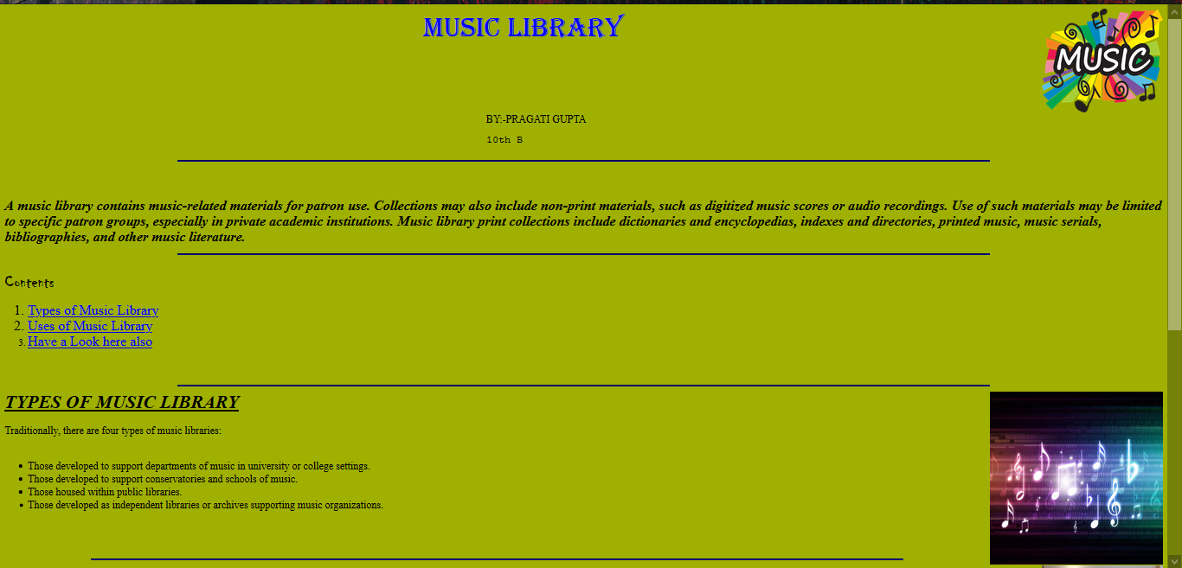

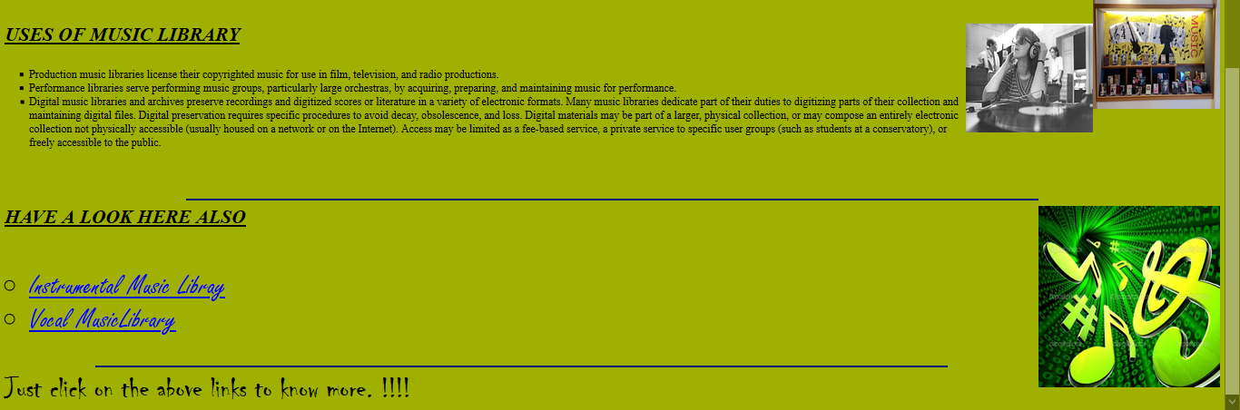

**Web page of Instrumental Music Library (Page-2)**

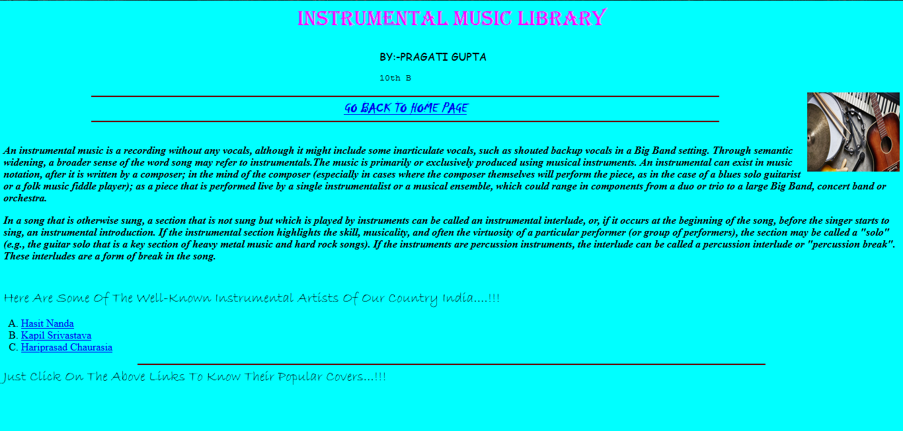

**Web page of Hasit Nanda (Page-3)**

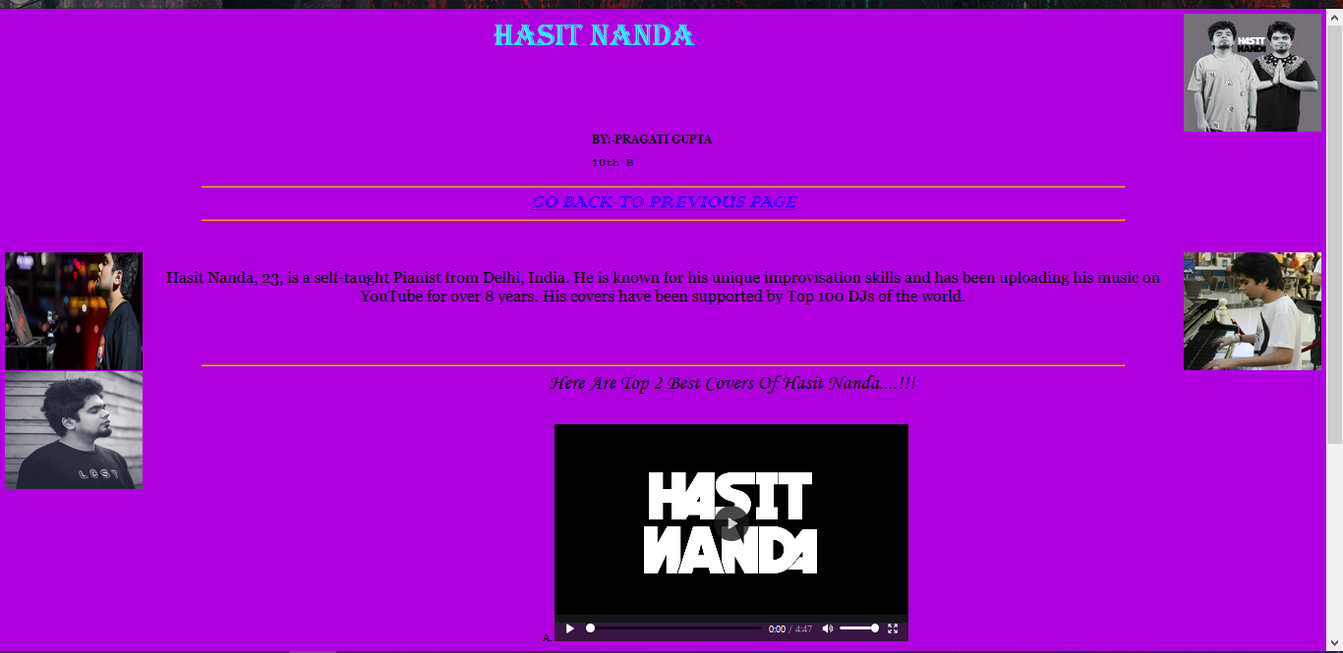



**Web page of Kapil Srivastava (Page-4)**

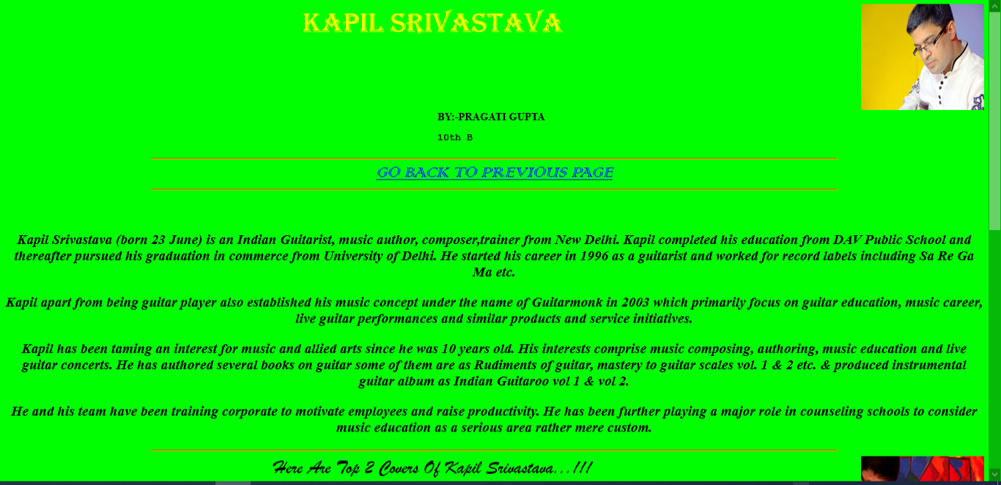

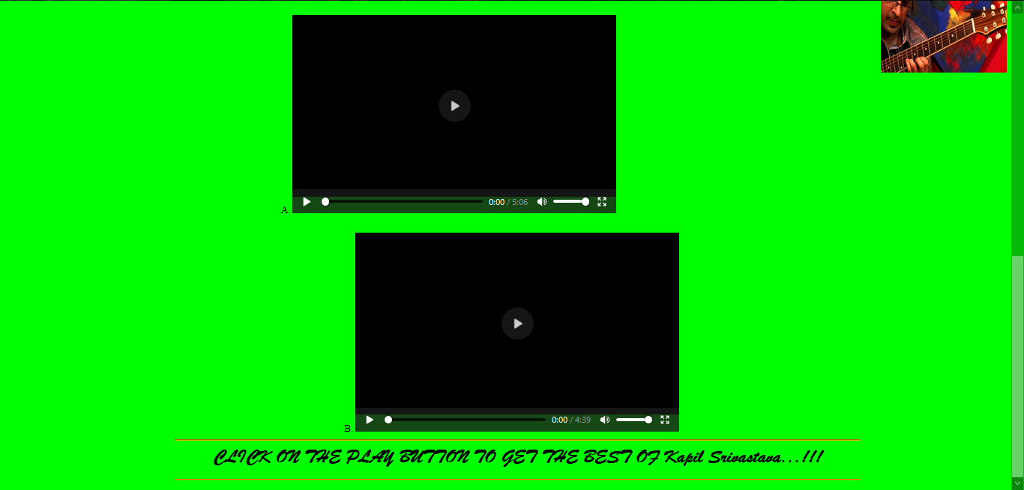

**Web Page of Hariprasad Chaurasia (Page-5)**

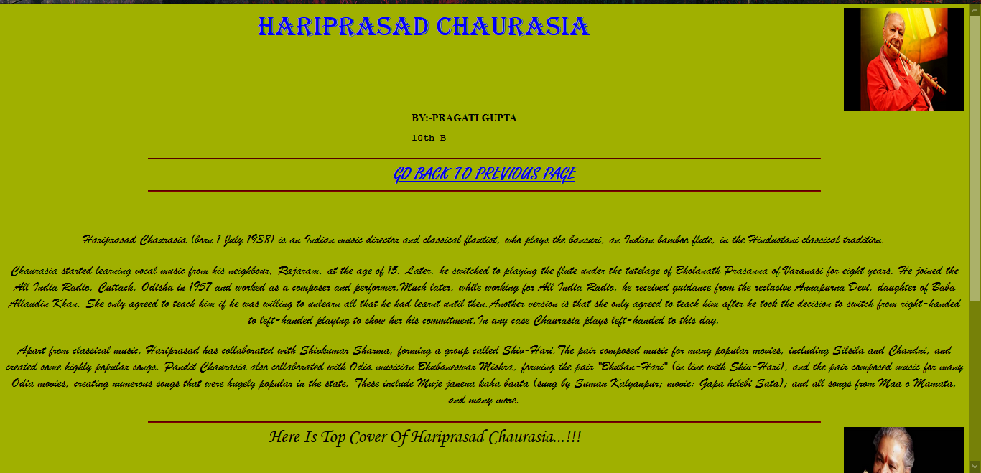

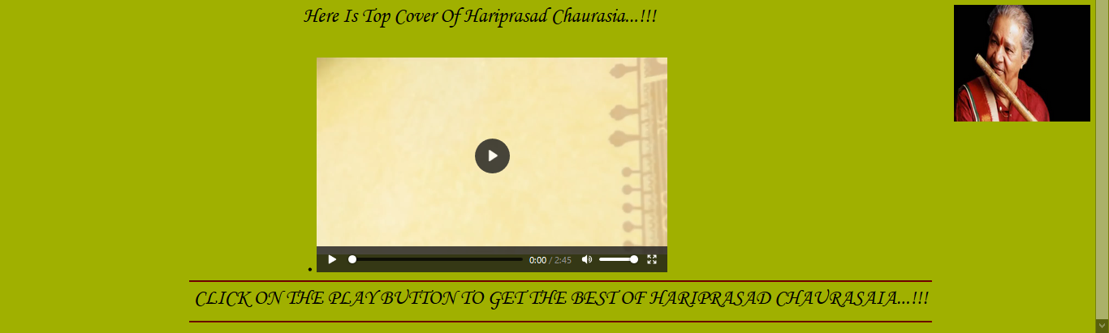

**Web Page of Vocal Music Library (Page -6)**

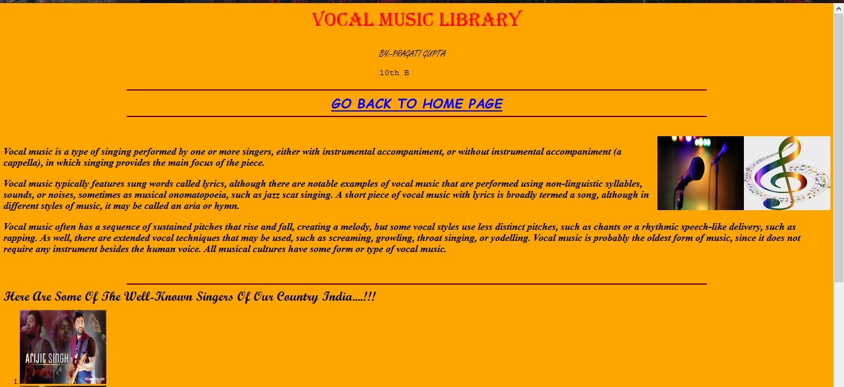

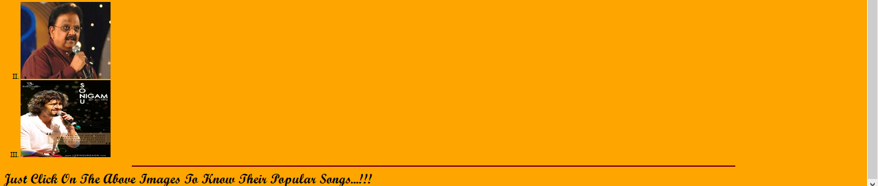

**Web page of Arijit Singh (Page-7)**

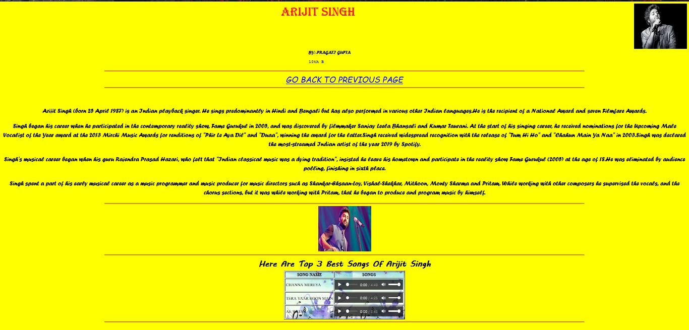

**Web page of S.P.Balasubramanyam (Page-8)**

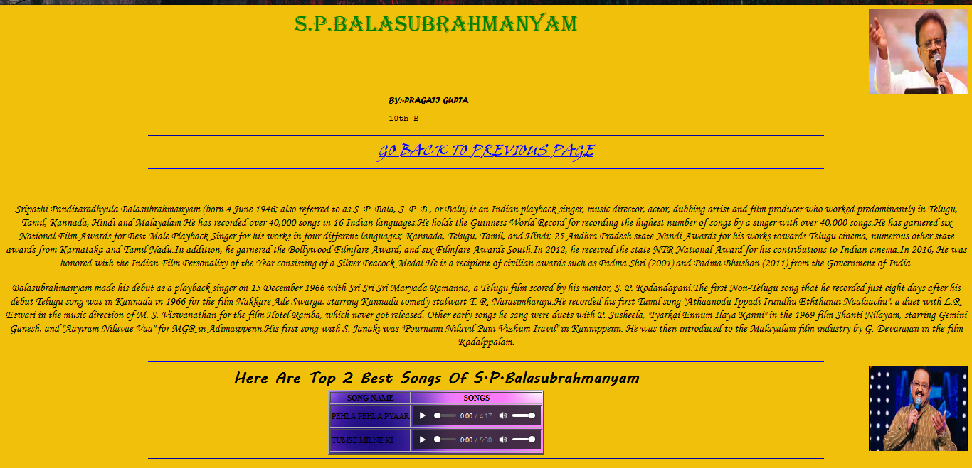

**Web page of Sonu Nigam (Page-9)**

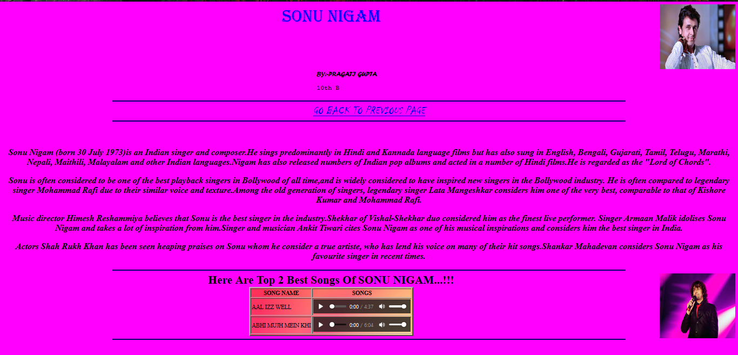

**Future scope**

Music is an art, form and cultural activity whose medium is sound.

The role of the music library in its political aspect is not only a reflection of the surrounding society but also as a predictor of the future since it is, more than any other kind of library, has to keep abreast of the current developments in the field. As music becomes less the sole domain of the performer and more a form of social activity, music libraries preserve music in its contemporary cultural form and, especially, can preserve music's ability to social, ideological and cultural criticism, and prophecy.

My web pages will be useful in future as they provide us top artists and their best covers. More artists and covers an also be easily added in these web pages.

Music Library has more scope in future as it is upgrading time by time.

**REFERENCES**

Books Used:

1. Cyber Beans class – Class-X

2. It Apps – Class-X

Websites:

1. [**GOOGLE**](http://www.gogle.com)
2. [**WIKIPEDIA**](http://www.wikipedia.org/)
3. [**STUDY.COM**](http://www.study.com)

**Thank You ☺**